**1. INTRODUCTION**

ONBS is online application for teachers and students to publish and update notice and related Information. In this 21st century, era of Computation and Information Technology, every part of our life is touched by Technologies. Taking a step further, the data that were handled manually before, are now computerized and accessed by large set of users. ONBS is a web application that can be accessed by the users within the Internet to view and to edit the content of the system.

**1.1 PROBLEM STATEMENT**

In the current scenario, student has to be present in college at the time of publishment of notice to be notified about the updated notice. Student who cannot be present in college due to certain circumstances has to visit personally or call at college or a friends to get updated about the notice. The content in the notice board cannot be managed all the time which leads to messiness or even loss of content. Due to the unmanaged notices it is hard to find the related notice by the concerned person. Student has to participate in crowd to view new and important notice. To publish a notice teachers have to personally print and pin it into the notice board. The archive of old notices are not kept which when needed in the future is not available. Concerned person has to regularly check all the notice board to see, if any new notice has been published.

**1.2 SOLUTION**

In response to the above mentioned problem, we have designed ONBS as a web application. A new notice can be published anytime in ONBS which reaches to all related person in sorted manner who are in the reach of internet. Even the notice can be modify anytime if needed with just some changes in notice with the help of ONBS online. By the use of ONBS student can be updated from anywhere and anytime. Student does not has to stand in the crowd to simply get detail notice. Since the notice is send to only related person finding a notice will no longer be a problem. A person can find all notices which had been published in earlier days since notices are listed according to dates.

**1.3 PROJECT OBJECTIVE**

* To provide an easy access to notices for all the students anywhere using internet.
* To provide students with an interface to view notices and teachers to add notice regarding related issues.
* To provide wide range of functionalities to teachers for managing the notices. It includes adding, editing and deleting the notices.
* To provide admin with the authority of assigning permissions on particular user to a particular functions.
* To provide backup of the previous notices.

**2. METHODOLOGY**

ONBS will be developed using a high level object oriented programming language, ASP.NET. Microsoft visual studio will be used for developing this application. .Net Framework 4.0 will be used as a framework. Microsoft visual studio will be used to program both the backend and frontend of the application.

CSS will be used for styling the web application. It will be used to design templates for master page, forms, buttons, navigation and other interface components.

jQuery, a popular JavaScript library will be used to provide further user interface functionalities. Itis a cross-platform JavaScript library designed to simplify the client-side scripting of HTML.

Microsoft SQL server management Studio will be used as database Manager. It is the database system developed by Microsoft.

**3 Work Plan**

**3.1 Time schedule**

1. Research 2 weeks
2. Software Architecture (model) 2 weeks
3. UI Designing 1 week
4. Database Designing 2 weeks
5. UI Coding 2 weeks
6. Core Coding 3 weeks
7. Documentation 1 week
8. Testing and Debugging 3 weeks

**3.2 Gantt Chart**

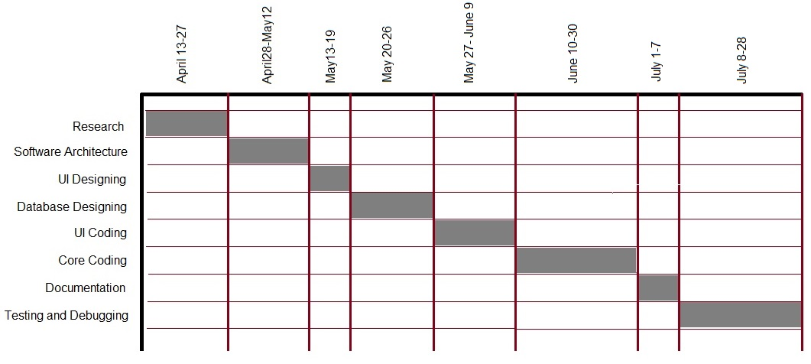

**4. LITRATURE REVIEW**

**4.1 CONTEXT DIAGRAM**

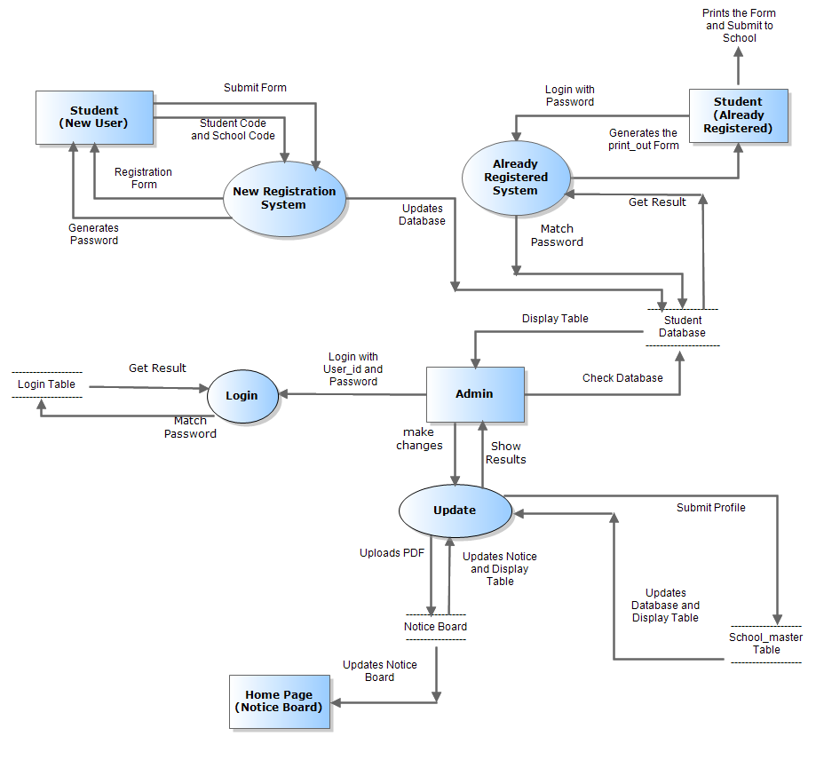

Fig 4.1 Context Diagram

**4.2 SYSTEM REQUIREMET**

* ISS Server to host ONBS
* Operating System with Browres.
* Internet Service to Browse Application in the web.

**5. Conclusion**

ONBS has the potential to replace the current method of managing the Notice because of its easy interface yet powerful functionalities. The application will be completed within 3-4 months with documentation, which will help in managing the application in future by other programmers. This application will certainly improve the workflow of handling the July .

**6. References**

* http://www.asp.net/web-forms/tutorials
* http://www.tutorialspoint.com/asp.net
* http://www.w3school.com
* Asp.net for Dummies

Author: Lynn Beighley

Wiley Publishing, Inc

* jQuery for Dummies

Author: Lynn Beighley

Wiley Publishing, Inc

* XHTML and CSS for Dummies

Author: Ed Tittel, Jeff Noble

Wiley Publishing, Inc

* https://www.youtube.com/user/kudvenkat

**7. ABBREBRATION**

**ONBS :** Online NoticeBoard System **ASP.Net :** Active server Page.Net **CSS :** Cascading Style Sheets **AJAX :**  Asynchronous JavaScript and XML **UI :** User Interface **IIS :** Internet Information Servics